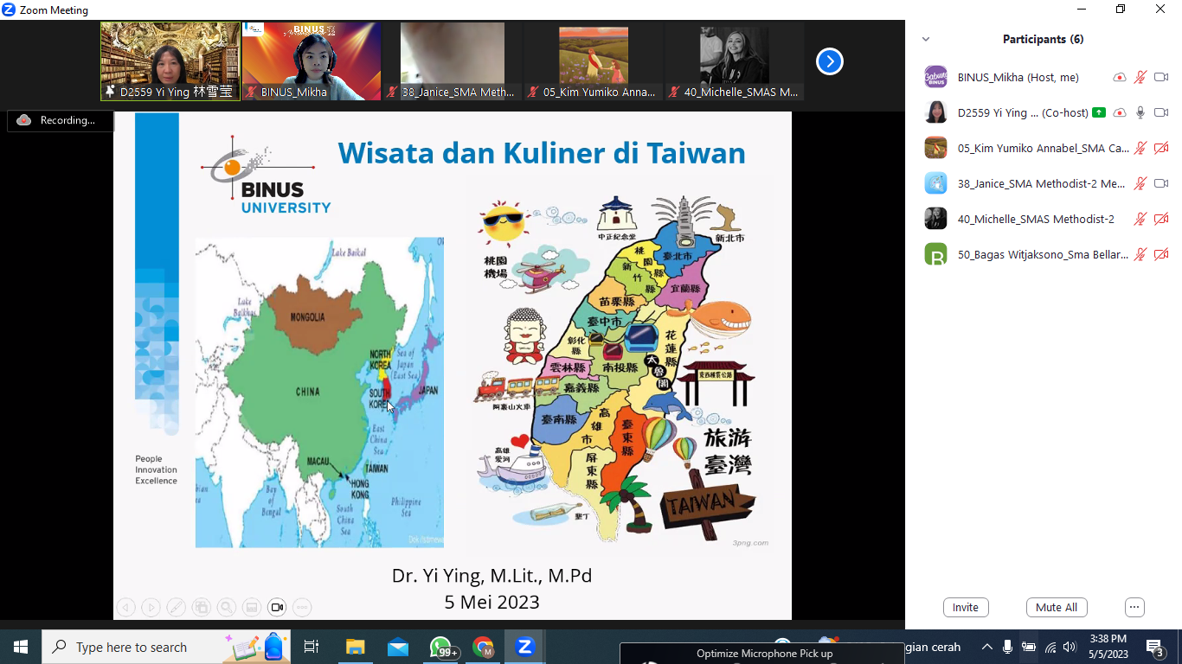

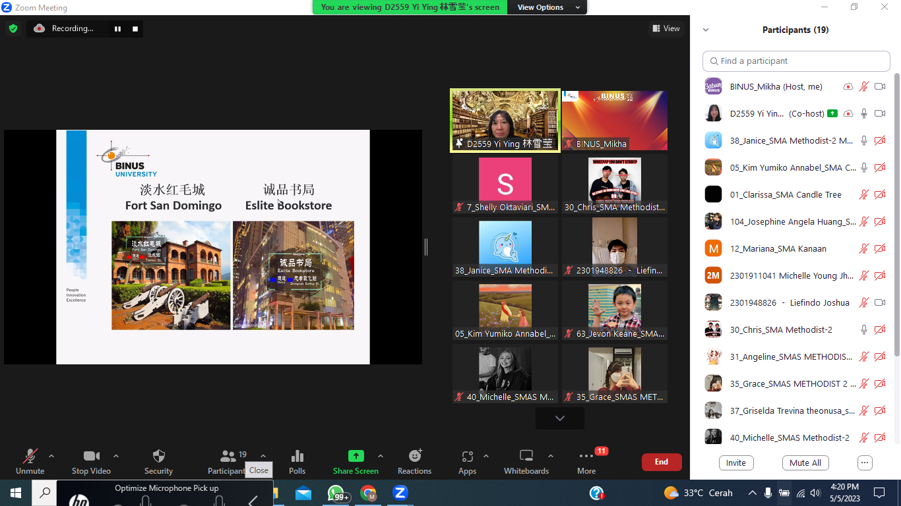

Figure 5 Learning Taiwan Tourism Area (2)

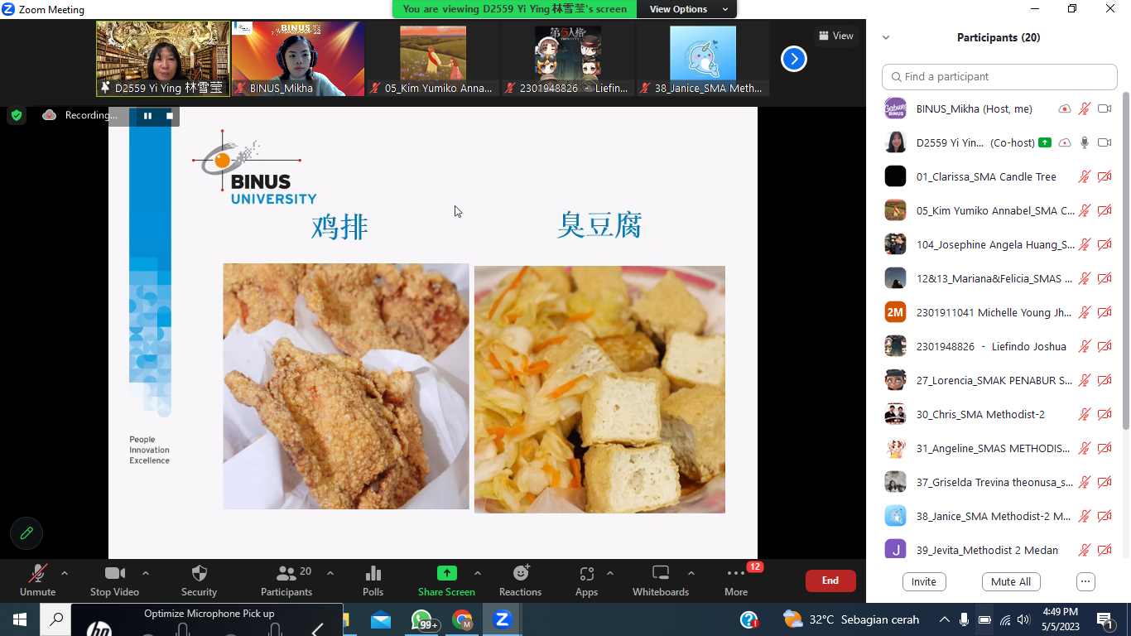

Figure 6 Learning Taiwan Tourism Area (3)

